EXPERIMENT NO-18: A DATABASE WITH NAME, DOB
Aim
To implement a Prolog database that stores people’s names and dates of birth, and allows queries to retrieve DOBs or names.
Algorithm
- Define facts in the database with person(Name, DOB).
- Store multiple entries with different names and DOBs.
- Write queries to:
  - Find DOB given a name.
  - Find names given a DOB.
- Execute queries to display results.
Prolog Code
prolog
% Database with Name and DOB

% Facts
person('Alice', '12-05-1995').
person('Bob', '23-11-1990').
person('Charlie', '01-01-2000').
person('Diana', '15-08-1998').

% Rule to get DOB by Name
get_dob(Name, DOB) :-
person(Name, DOB).

% Rule to get Name by DOB
get_name(DOB, Name) :-
person(Name, DOB).
Output
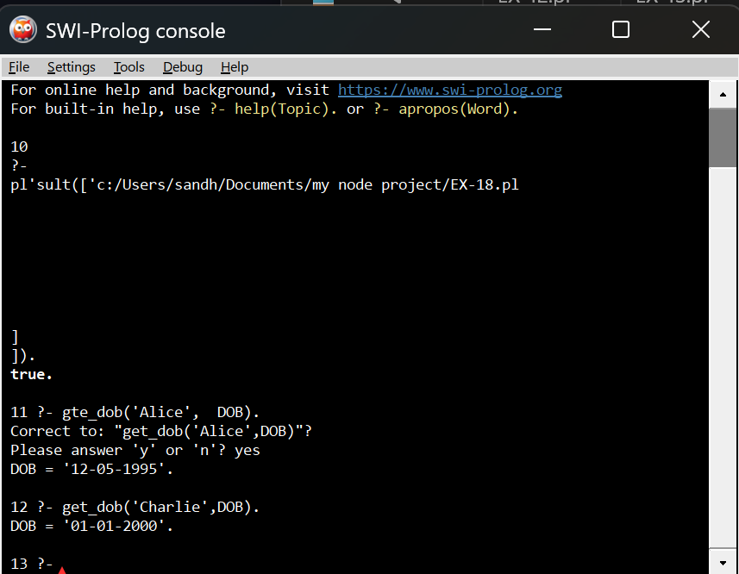
Result
The Prolog database successfully stores names and DOBs. Queries can retrieve either the DOB for a given name or the name for a given DOB, demonstrating a simple fact-based database system.

